3Q 6th Grade Final Exam SBG
Level 1
True or False. If False write the correct term that makes the statement true.
1._____Gravity is the attraction between all objects in the universe
2._____ Lubricants are the force that opposes the motion of an object.
3._____ Vacuum is empty room.
4. ____ Air pressure is caused by the force exerted by the Sun’s atmosphere.
5. ____Action and reaction force are part of Newton’s third law of motion.

Level 2
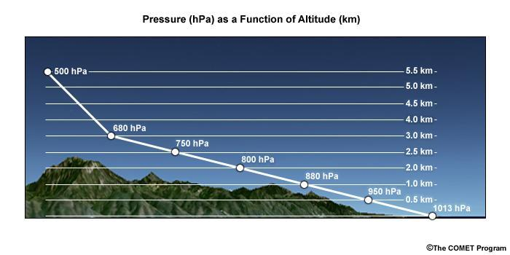
6. This graph represents which statement.
a. air pressure increases as altitude increases c. air pressure decreases as altitude decreases
b. air pressure decreases as altitude increase d. none on the above

7. If you blow on top of a sheet of paper it will rise because
a. air pressure above the sheet of paper has decreased c. it is demonstrating Bernoulli’s Principle
b. it shows how airplane wings have the force called lift d. all of the above
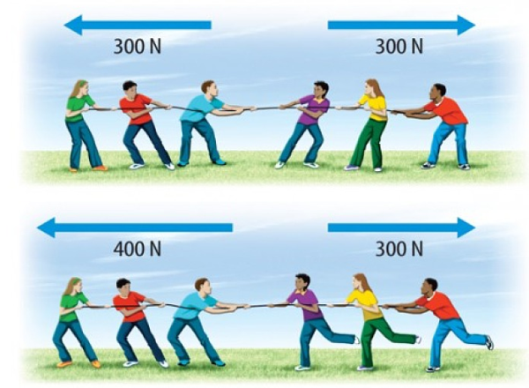
8. The top diagram is an example of what type of force?

9. The bottom diagram is an example of what type of force?

10. All of these are types of friction that can be changed to make motion possible except one
a. rolling b. sliding c. useful d. lubricants

Level 3 Answer Questions and provide Examples
- Describe Newton’s 1st Law of Motion and provide and example.
- Describe Newton’s 2nd Law of Motion and provide and example.
- Describe Newton’s 3rd Law of Motion and provide and example.
Level 4

Explain your Proa design through science. Using your understanding of motion explain the function of each part of your design and how does it create motion and speed, velocity and acceleration, momentum, and which laws of motion are applied to make the Proa function.

